**20TCS078_PRUTHURAJ**

**Question 1** :- Explain the basic and detailed structure of C.

**Answer 1** :-

**Introduction** :- The C programming language came into existence when its developers were working on the development of the Unix operating system using the B language, out of which C evolved. The B language lacked certain features that led to the introduction of C. These features constituted the part of the C program upon which it was is built.

* **Basic Structure of C Program**

The components of the basic structure of a C program consists of 7 parts.

**1. Document section** :- It is the section in which you can give comments to make the program more interactive. The compiler won’t compile this and hence this portion would not be displyed on the output screen.

**2. Preprocessor/link Section** :- This section involves the use of header files that are to included necessarily in the program.

**3. Definition section** :- This section involves the **Variable Definition and Declaration in C**

**4. Global declaration section** :- This section is used to define the global variables to be used in the program, that means you can use these variables throughout this program.

**5. Function declaration section** :- This section gives the information about a function that includes, the data type or the return type, the parameters passed or the arguments.

**6. Main function** :- It is the major section from where the execution of the program begins. The main section involves the declaration and the executable section.

**7. User-defined function section** :- When you want to define your function that fulfills a particular requirement, you can define them in this section.

**STEPS INVOLVED TO GET THE DESIRED OUTPUT** :-

1. Create
2. Compile
3. Execute or Run

Try to code the program in the most precise manner following the protocols of C programming like;

* C is case sensitive programming language
* Each line of the code in C ends with a semicolon **(;)** , except the function definition.

**Question 2** :- Explain the features of C programming.

**Answer 2** :-

*C Programming language is a widely used language. It provides a lot of features as given below:-*

1. **Simple:-** C is a simple language in the sense that it provides **structured approach** (to break the problem into parts), **rich set of library functions, data types,** etc.
2. **Machine Independent or Portable:-** Unlike assembly language, C programs **can be executed on many machines** with a little bit or no change. But it is not platform dependent.
3. **Mid-level programming language:-** C is **also used to do low-level programming**. It is used to develop system applications such as kernel, driver etc. It **also supports the feature of high level language**. That is why it is known as mid-level language.
4. **Structured programming language:-** C is a structured programming language in the sense that **we can break the program into parts using functions**. So, it is easy to understand and modify.
5. **Rich Library:-** C **provides a lot of inbuilt functions** that make the development fast.
6. **Memory Management:-** It supports the feature of **dynamic memory allocation**. In C language, we can free the allocated memory at any time by calling the **free()** function.
7. **Speed:-** The compilation and execution time of C language is fast.
8. **Pointer:-** C provides the feature of pointers. We can directly interact with the memory by using the pointers. We can use **pointers for memory, structures, functions, array etc.**
9. **Recursion**:- In c, we can **call the function within the function.** It provides code reusability for every function.
10. **Extensible:-** C language is extensible because **it can easily adopt new features.**

**Question 3 :-** Mention 5 benefits of C language with examples**:-**

**Answer 3 :-**

**Benefits of C Language**

1. As a middle-level langauge, C combines the features of both, hig-level language and low level languages. ***It can be used for low level programming, such as scripting for drivers and kernels and it also supports functions of high-level programming languages, such as scripting for software applications, etc.***
2. C language implements algorithms and data structures swiftly, facilitating faster computations in programs. This has enabled the use of C in ***applications requiring higher degrees of calculations like MATLAB & Mathematica.***
3. Various features of C including direct access to machine level hardware APIs, the presence of C compilers, deterministic resource use and dynamic memory allocation make C language an optimum choice for ***scripting applications and drivers of embedded systems.***
4. C language is a highly portable language and is used for scripting sysytem application ***which forms a major part of Windows, Unix, and Linux operating system.***
5. C language is a general purpose programming language and ***can efficiently work on enterprise applications, games, graphics, etc.***

**Question 4 :-** Write a program to drawhearts using ASCII value, ranging from 5 in rows till 1 in a row.

**Answer 4 :-**

**INPUT**

**OUTPUT**



**Question 5 :-** Write a program to display ASCII value of a character entered by the user.

**Answer 5 :-**

**INPUT**

**OUTPUT**

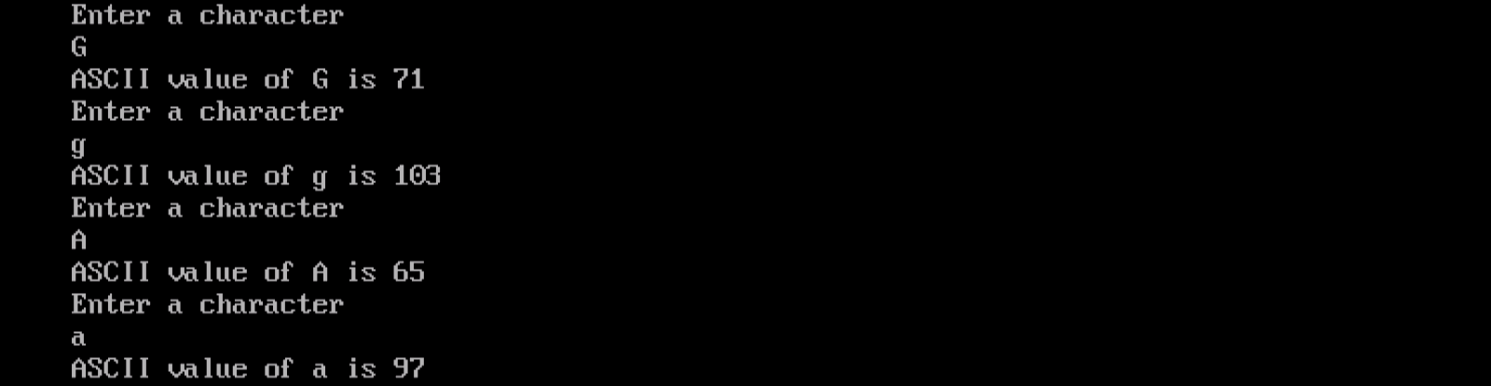

**------------------------------------------x------------------------------------------**

**Thanks**

**Regards, Pruthuraj Suthar**